<< AI ASSISTED CODING

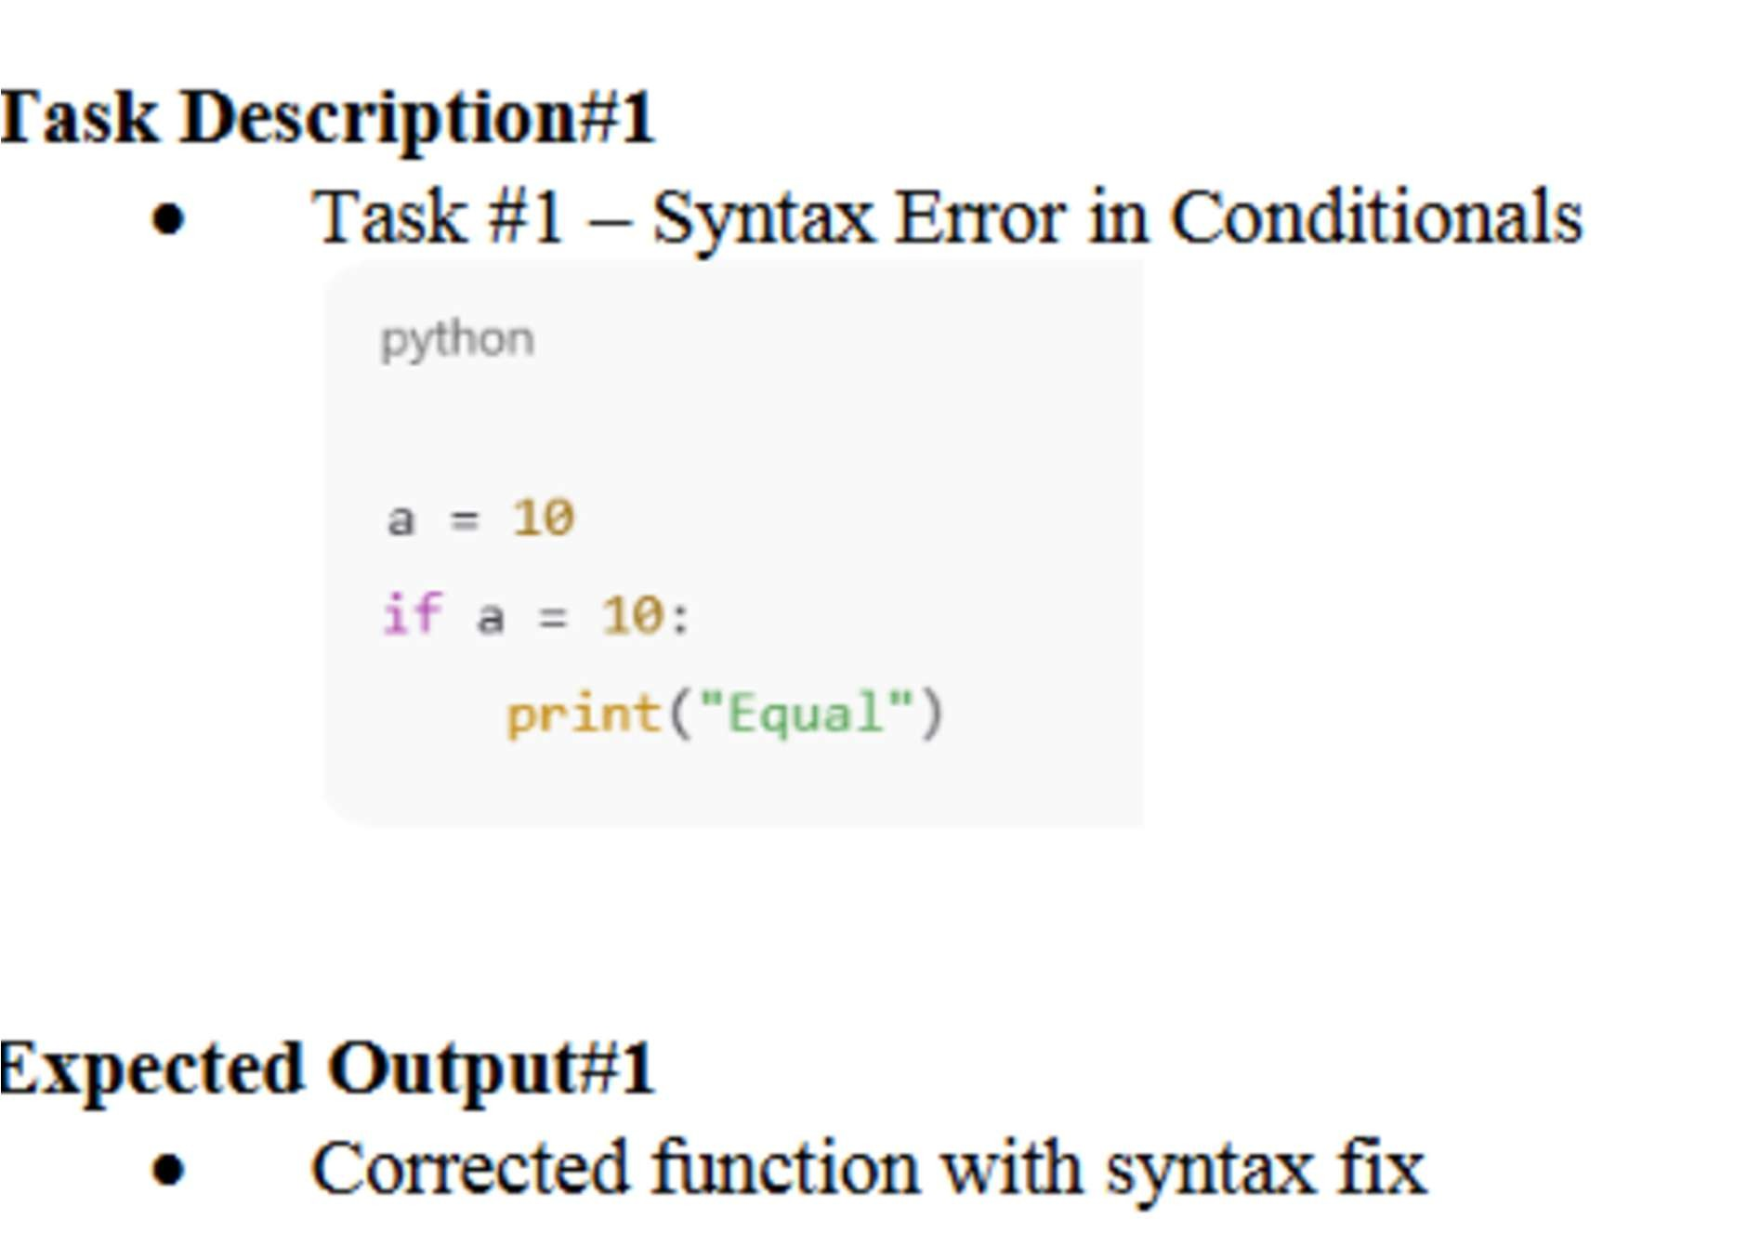
Prompt: The following Python code contains a syntax error in its condi onal statement: a = 10 if a = 10: print("Equal") Iden fy the error in the if statement and rewrite the code to produce the expected output.
Errors of the code:
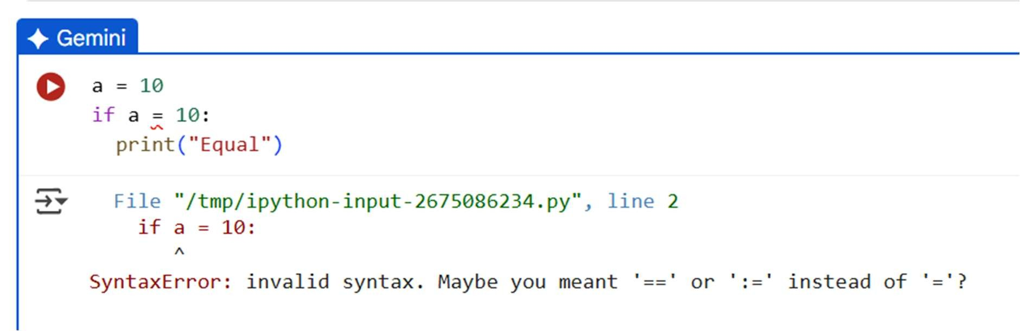
Modification of the code:
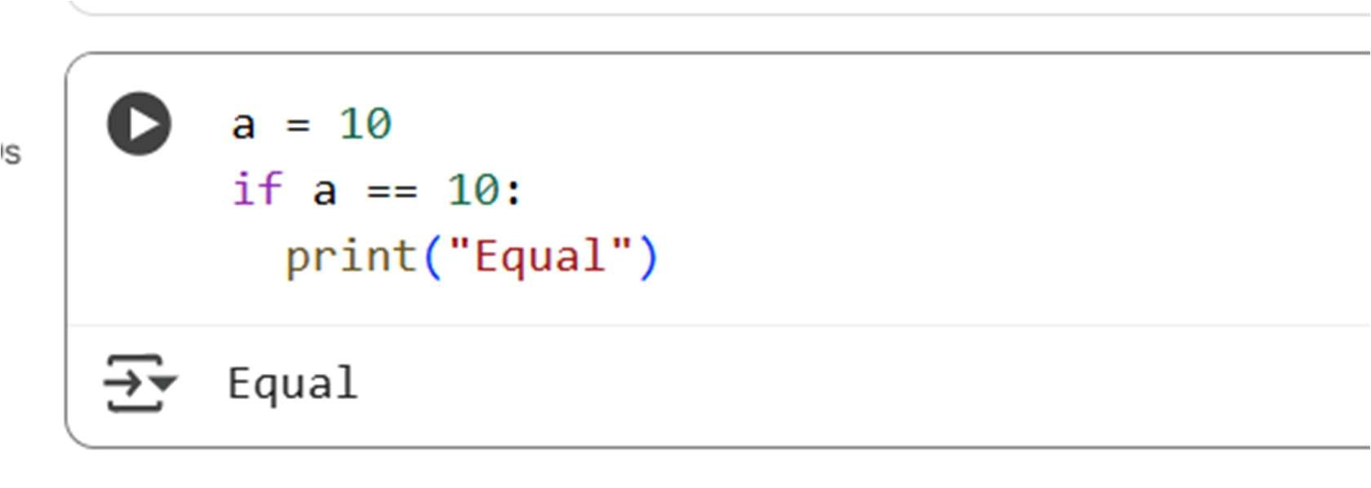
Explanation of code:
This cell first assigns the value 10 to the variable a. Then, it checks if the value of a is equal to 10 using the if statement and the equality comparison operator (==). Since a is indeed equal to 10, the code inside the if block is executed, which prints the word "Equal".
Observation:
- Code with the original error: You can see the code with the SyntaxError in cells . Both of these cells ini ally had if a = 10: which caused the error. The output below these cells shows the SyntaxError: invalid syntax message.
- Code a er fixing the error: I corrected the error in cells and by changing if a = 10: to if a == 10:.
- Output of the corrected code: When the corrected code in cells b8 8qYC3wHDiWPD, and it is executed, the output is "Equal" because the condi on a == 10 is true. In cell a er fixing the syntax error, the output is "Equal" due to the type in the print statement.

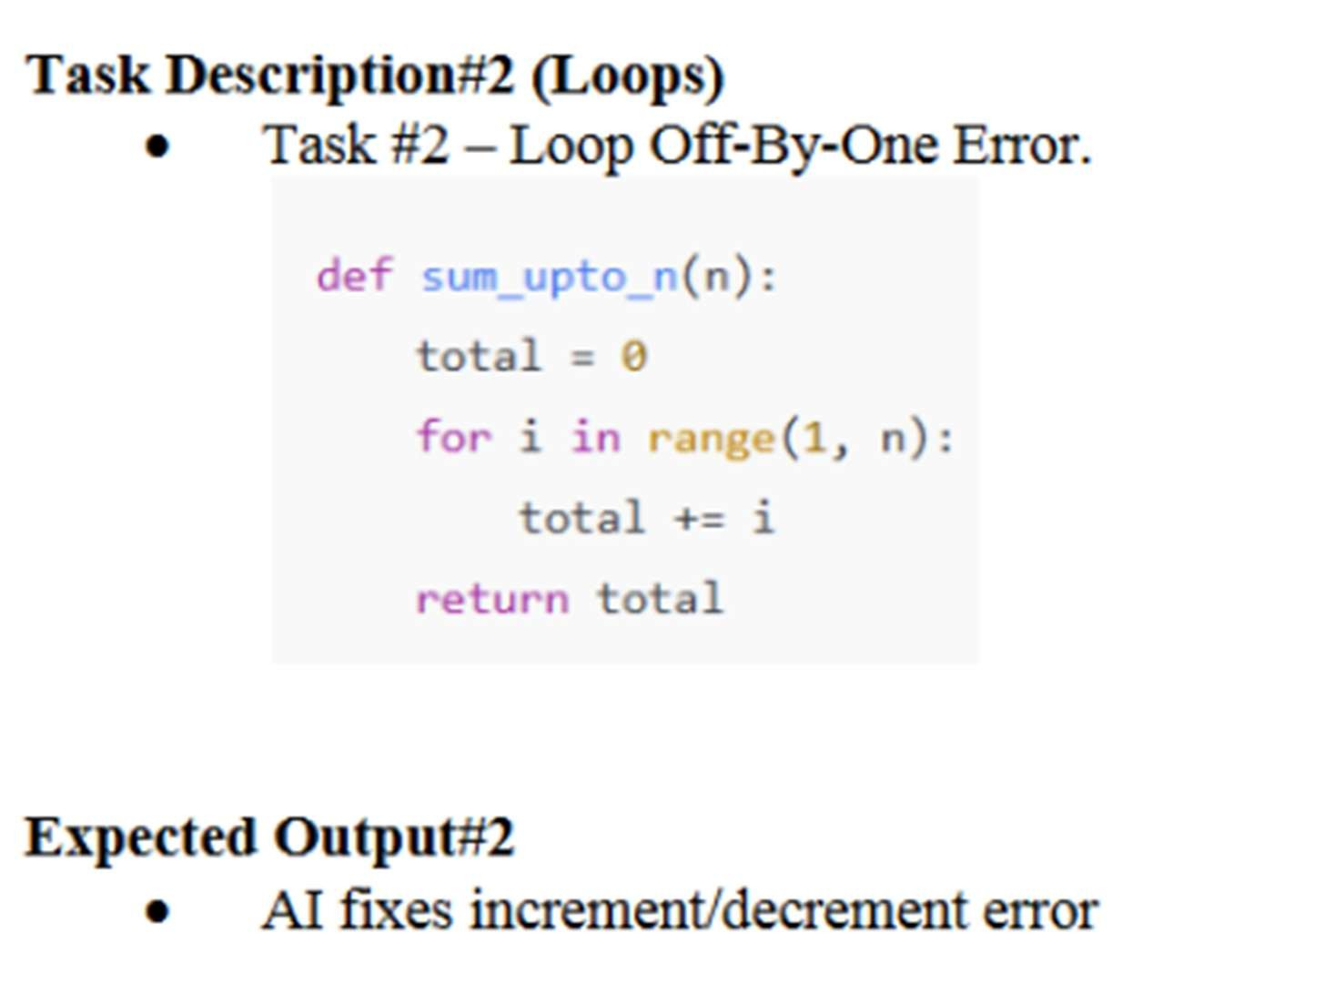
Prompt:
Examine the following Python func on intended to calculate the sum of integers from 1 to n: def sum_upto_n(n):
total = 0 for i in range(1, n): total += i return total
The func on currently returns an incorrect result due to a loop boundary issue. Can you iden fy and fix the off-by-one error so the func on correctly includes n in the summa on?

Errors in the code:
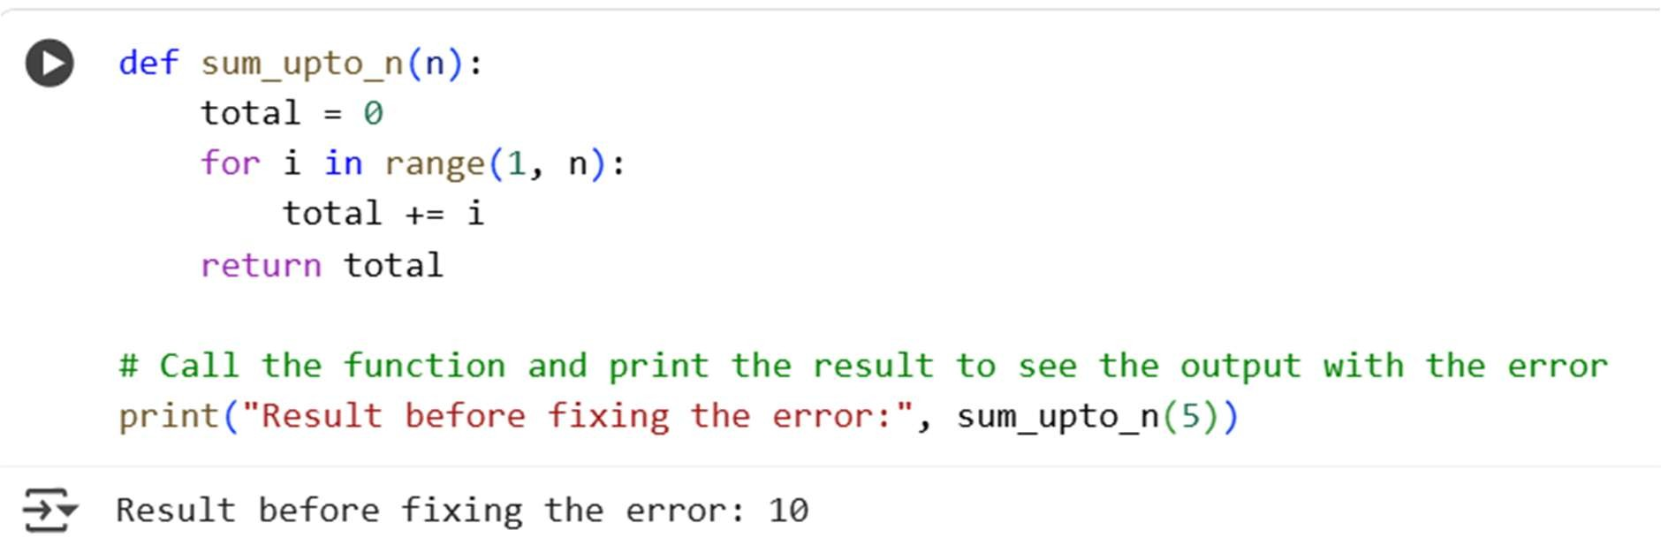
Modification of code:
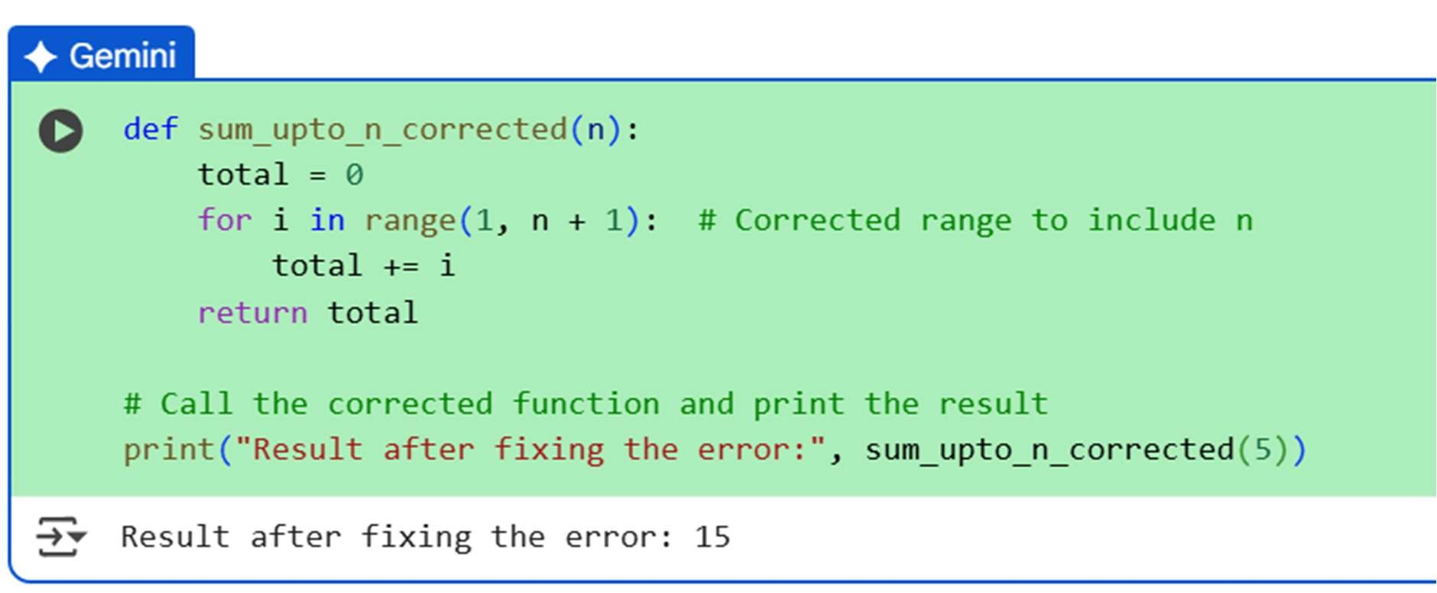
Explanation of code:
This cell defines a Python func on called sum_upto_n that takes one argument, n.
- It ini alizes a variable total to 0.
- It uses a for loop with range(1, n). This loop iterates through numbers star ng from 1 up to, but not including, n.
- In each itera on, it adds the current number i to total.
- Finally, it returns the calculated total.
- A er the func on defini on, it calls the sum_upto_n func on with the argument 5 and prints the returned result along with a descrip ve string. As we've discussed, this func on has an off-by-one error because range(1, n) does not include n in the summa on.

Observation:
- Syntax Error Correc on: Several cells ini ally had a SyntaxError due to using = instead of == in the if statement. These errors have been corrected, and the code now runs without syntax errors.
- Equality Comparison: Cells all demonstrate the use of the equality comparison operator == in an if statement. When the condi on a == 10 is true, the code inside the if block is executed.
- Off-by-One Error Demonstra on: Cell _U contains the sum_upto_n func on with an off-by-one error in the range func on. The output of this cell (Result before fixing the error: 10) clearly shows that the func on is not including the upper limit n (5 in this case) in the summa on, as the sum of 1 to 5 should be 15.

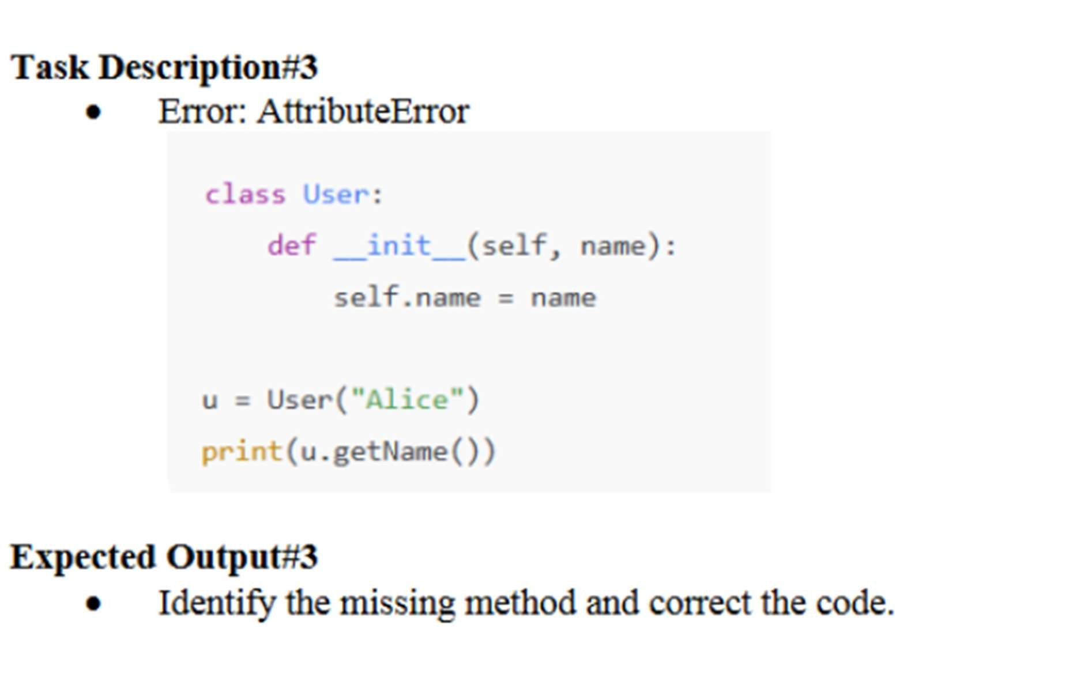
Prompt:
Consider the following Python class defini on and usage: class User: def __init__(self, name): self.name = name u = User("Alice") print(u.getName())
Running this code results in an A ributeError.
Can you iden fy the cause of the error and modify the class so that it correctly prints the user's name?
Errors in the code :
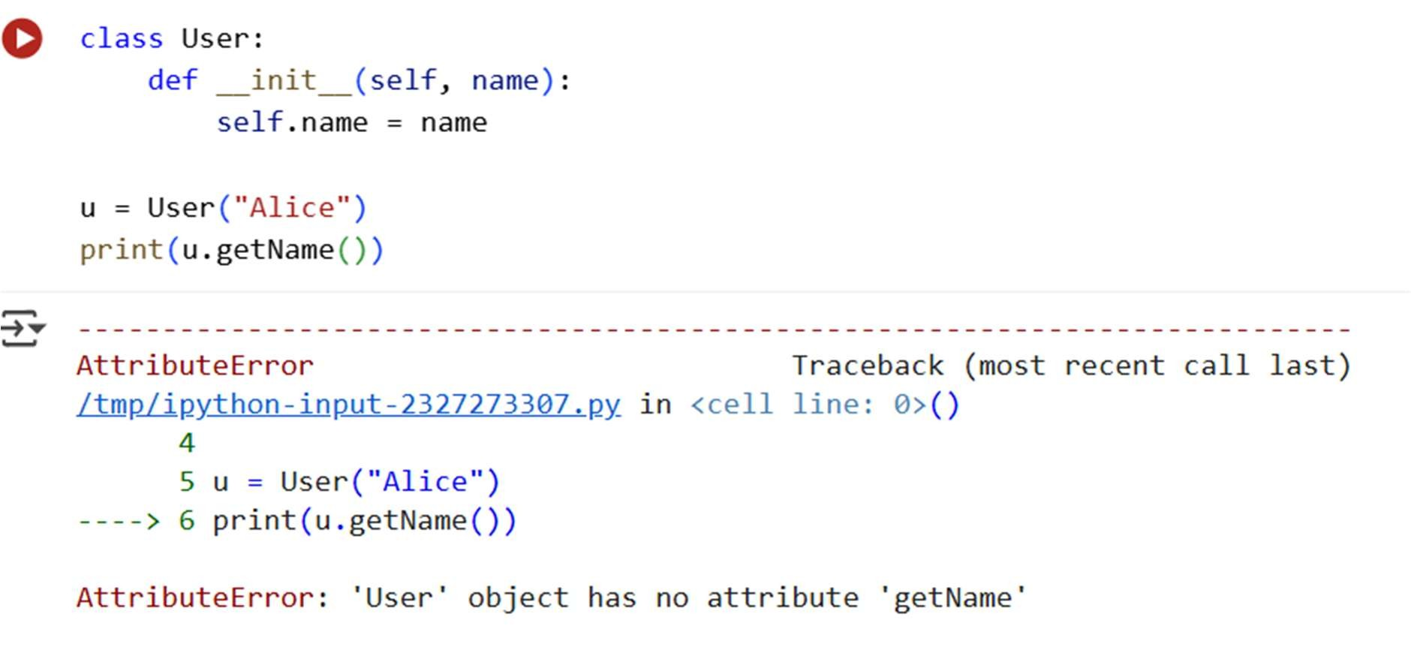
Modification of code:
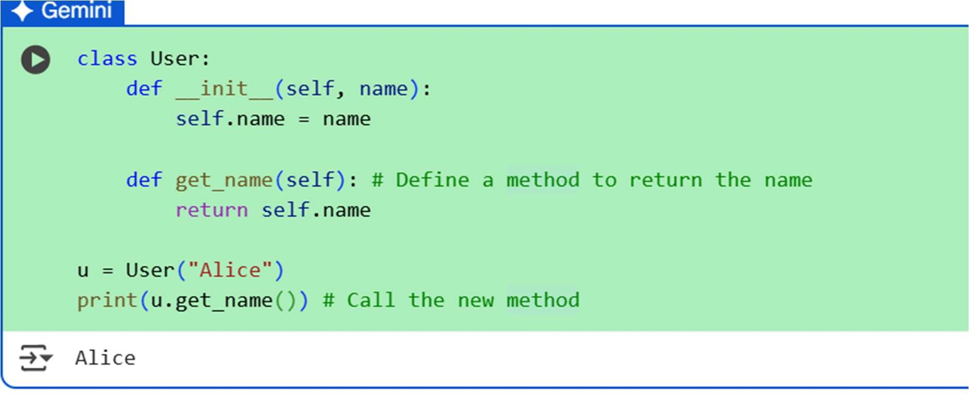
Explanation of code:
- The __init__ method is the constructor; it's called when you create a new User object. It takes self (which refers to the instance of the class) and a name argument, and it stores the name in an a ribute called self.name.
- The code then creates an instance of the User class named u, passing "Alice" as the name.
- Finally, it a empts to call a method named getName() on the u object and print its return value. This is where the A ributeError occurs because no method named getName is defined within the User class.

Observation
- Class Defini on and A ributes: Cell shows a basic Python class defini on (User) and how to create an instance of that class. It also highlights that you can store data as a ributes (self.name) within the class instance.
- A ributeError: Cell illustrates an A ributeError, which occurs when you try to access or call an a ribute or method on an object that does not exist. In this case, the User object did not have a getName() method.
- Error Iden fica on and Correc on: The sequence of interac ons related to both the SyntaxError and the A ributeError shows the process of iden fying the error based on the traceback, understanding the cause, and then modifying the code to correct it.

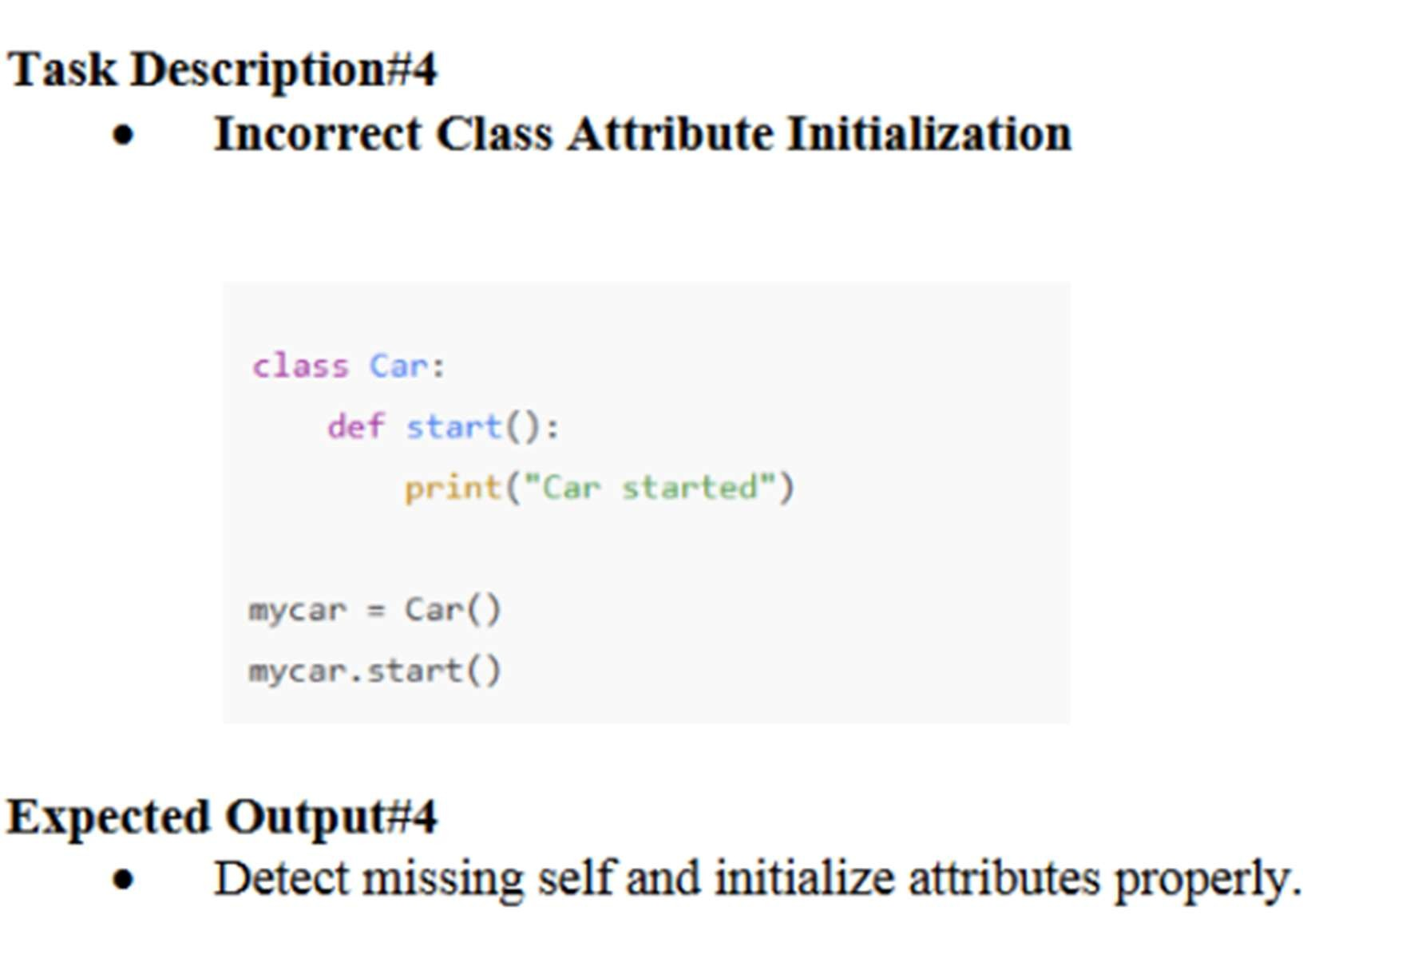

Prompt:

Examine the following Python class defini on and method call:
class Car: def start(): print("Car started") mycar = Car() mycar.start()
Running this code results in a TypeError because of incorrect method defini on.
Can you iden fy the issue with the start() method and rewrite the class so that the method works properly ?

Errors in the code:
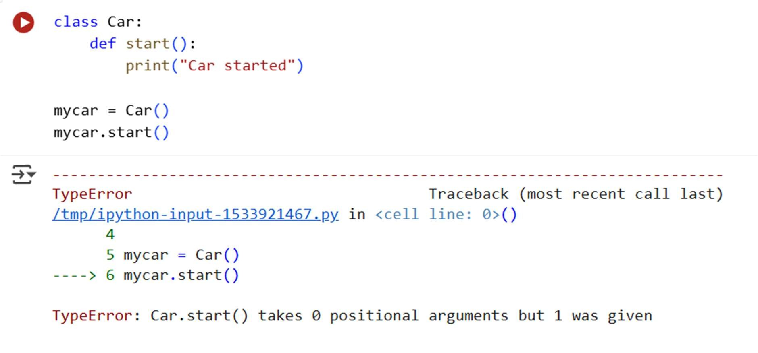
Modification of code:
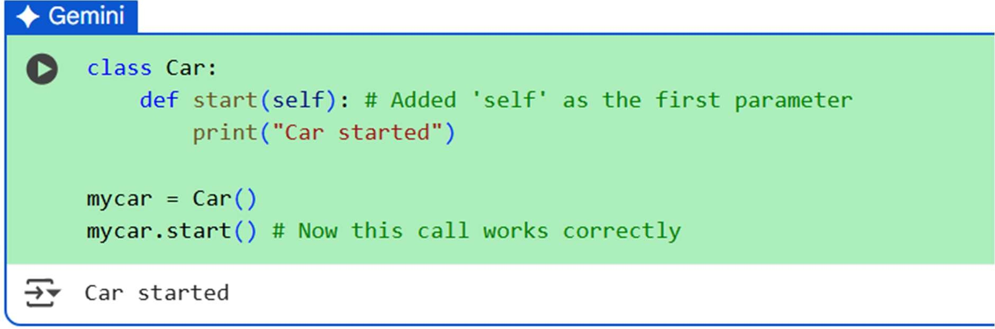
Explanation of code:
- It defines a method called start(). However, this method is defined without the required self parameter, which is a conven on in Python for instance methods to refer to the object itself.
- It then creates an instance of the Car class named mycar.
- Finally, it a empts to call the start() method on the mycar object. This call implicitly passes the mycar instance as the first argument, but since the start() method is defined to take no arguments, a TypeError occurs.

Observation :
- Importance of self in Class Methods: Cell specifically highlights the necessity of including self as the first parameter in instance method defini ons within a class. Failing to do so results in a TypeError when the method is called on an object instance.
- Debugging Process: The sequence of interac ons demonstrates a typical debugging process:
encountering an error, iden fying the error type and traceback, understanding the cause of the error, and modifying the code to fix it.
- Code Evolu on: You can see the evolu on of the code as errors are iden fied and corrected across different cells.

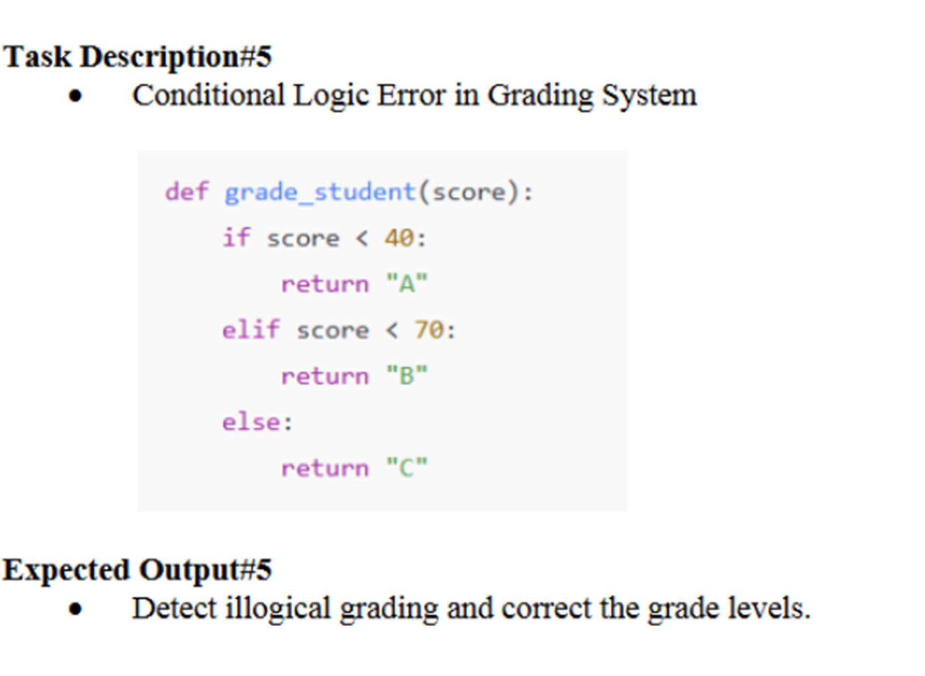
Prompt:
Review the following Python func on designed to assign grades based on a student's score: def grade_student(score): if score < 40: return "A" elif score < 70: return "B" else: return "C"
The current grading logic is flawed—lower scores are receiving higher grades.
Can you iden fy the issue and rewrite the func on so that higher scores receive be er grades?
Errors in the code:

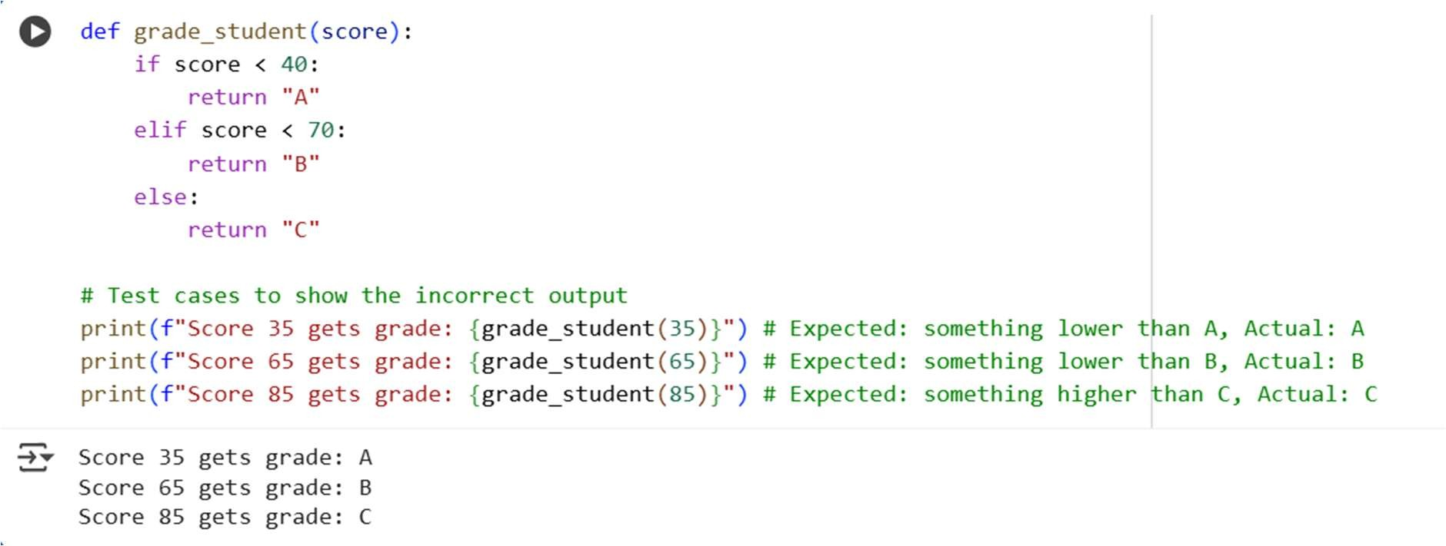
Modification of code:
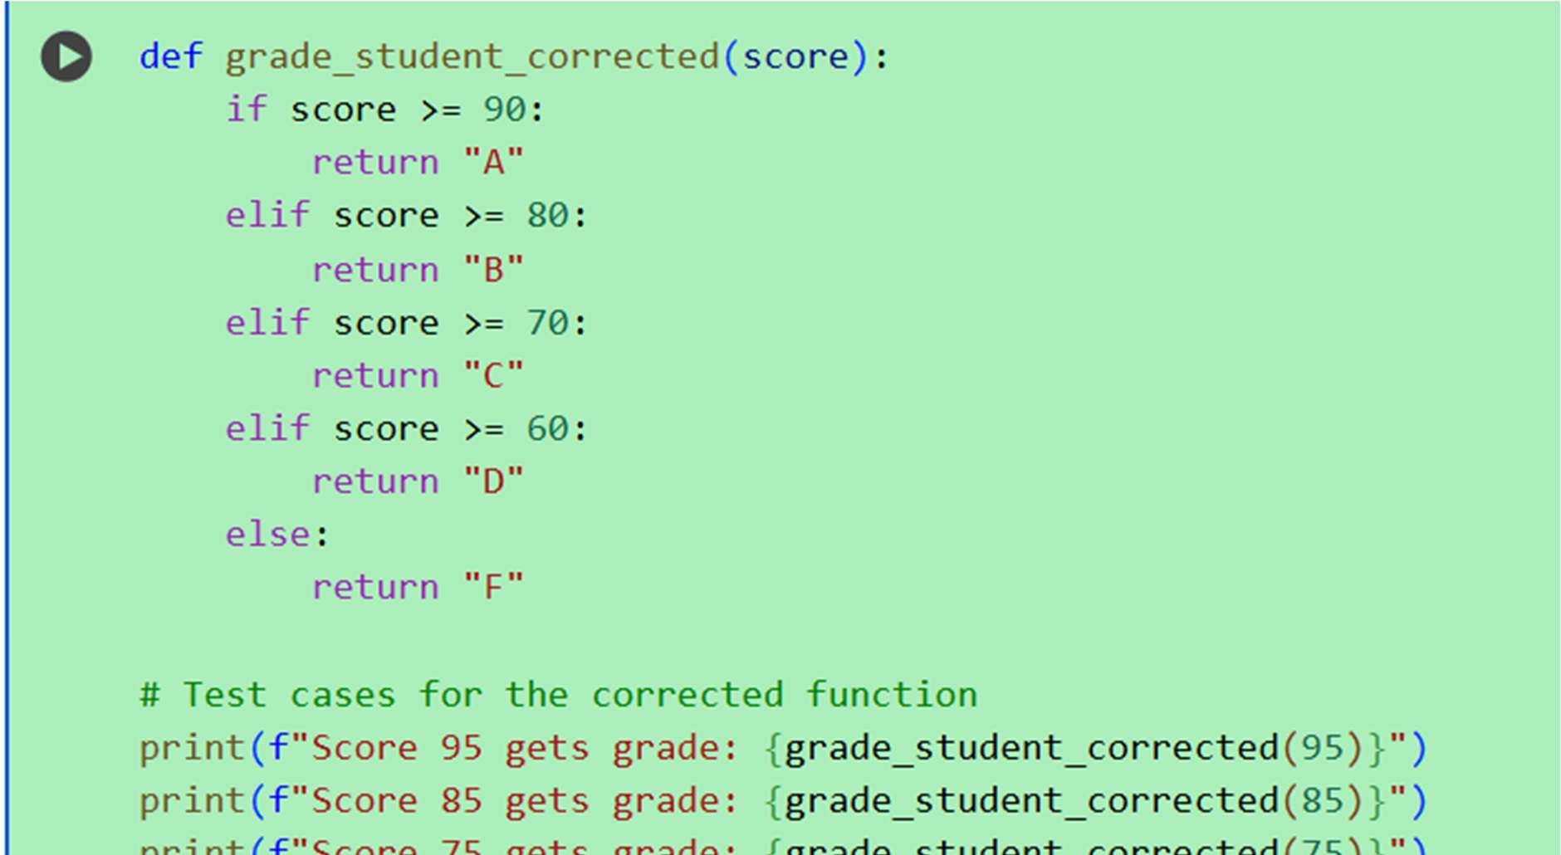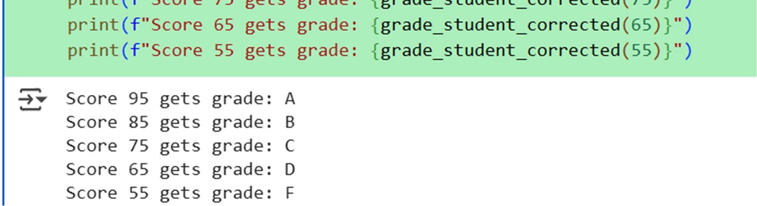
Explanation of the code:
- It uses a series of if and elif (else if) statements to check the score against different thresholds.
- If the score is less than 40, it returns "A".
- If the score is not less than 40 but is less than 70, it returns "B".
- Otherwise (if the score is 70 or greater), it returns "C".
- The code then calls this func on with scores 35, 65, and 85 and prints the returned grades. As noted, this logic assigns grades in reverse order of a typical grading system.
Observation:
- Demonstra on of Condi onal Logic: The cells effec vely demonstrate how if, elif, and else statements are used in Python to execute different blocks of code based on condi ons. This is par cularly clear in the grading func on example .
- Comparison Operators and Order: The grading func on highlights the importance of the order of condi onal checks and the correct use of comparison operators (<, >=). The ini al flawed logic showed what happens when the condi ons are not structured to reflect the desired outcome (higher scores ge ng be er grades).
- Func on Defini on and Return Values: The sum_upto_n (jGBNane-ot_U) and grade_student func ons illustrate how to define func ons, take arguments, perform opera ons, and return a result using the return keyword.
- Class Basics: The User and Car class examples introduce basic object-oriented programming concepts.

